Mission Statement of the Department.
To nurture computer engineering professionals by offering Dynamic learning environment that encourages problem-solving using emerging technology, National Education Policy aligned evidence-based technical education, fostering ,innovation, research, and industry–institute collaboration & Holistic, ethical and sustainable development for lifelong success.

Session 2026-2027

Vision:Dream of where you want. | Mission: Means to achieve Vision

Program Educational Objectives of the program (PEO): (broad statements that describe the professional and career accomplishments)
PEO1 | Preparation | P: Preparation | Pep-CL abbreviation pronounce as Pep-si-lL easy to recall
PEO2 | Core Competence | E: Environment  (Learning Environment) | Pep-CL abbreviation pronounce as Pep-si-lL easy to recall
PEO3 | Breadth | P: Professionalism | Pep-CL abbreviation pronounce as Pep-si-lL easy to recall
PEO4 | Professionalism | C: Core Competence | Pep-CL abbreviation pronounce as Pep-si-lL easy to recall
PEO5 | Learning  Environment | L: Breadth (Learning in diverse areas) | Pep-CL abbreviation pronounce as Pep-si-lL easy to recall

Program Outcomes (PO): (statements that describe what a student should be able to do and know by the end of a program)
Keywords of POs:
Engineering knowledge,Problem analysis, Design/development of solutions,Conduct Investigations of Complex Problems, Engineering Tool Usage, The Engineer and The World,Ethics, Individual and Collaborative Team work,Communication, Project Management and Finance, Life-Long Learning

PSO Keywords: Cutting edge technologies, Research

“I am an engineer, and I know how to apply engineering knowledge to investigate, analyse and design solutions to complex problems using tools for entire world following all ethics in a collaborative way with proper management skills throughout my life.” to contribute to the development of cutting-edge technologies and Research.

Integrity: I will adhere to the Laboratory Code of Conduct and ethics in its entirety.

Name and Signature of Student and Date
(Signature and Date in Handwritten)

To nurture computer engineering professionals by offering Dynamic learning environment that encourages problem-solving using emerging technology, National Education Policy aligned evidence-based technical education, fostering ,innovation, research, and industry–institute collaboration & Holistic, ethical and sustainable development for lifelong success.

Session | 2026-27 (ODD) | Course Name | Web Technology Lab
Semester | 3 | Course Code | 23CT1301
Roll No | 49 | Name of Student | Devanshu Parshionikar

Practical Number | 7
Course Outcome | - Understand various internet technologies.  - Design the web pages using HTML and CSS.  - Implement the XML technology to store the data.  - Develop the interactive web pages using JavaScript.
Aim | JavaScript — Asynchronous Programming (Fetch/Promises)
Problem Definition | Build a small Weather App or Movie-Search App that fetches data from ONE public API using fetch()/async-await and renders it dynamically.
Theory  (100 words) | JavaScript asynchronous programming relies on Promises to handle operations that take time, such as network requests via the Fetch API, without blocking the main thread. The fetch() method returns a Promise that resolves to a Response object, allowing developers to chain .then() and .catch() methods or use the cleaner async/await syntax to wait for results.  Using Async/Await simplifies code readability by pausing execution until the promise resolves, enabling standard try...catch error handling. To perform parallel requests, developers use Promise.all() to wait for multiple fetch calls to complete simultaneously, which is more efficient than sequential requests.  Key Concepts:  - Promises: Objects representing the eventual completion or failure of an async operation.  - async Functions: Always return a Promise; allow the use of await.
To nurture computer engineering professionals by offering Dynamic learning environment that encourages problem-solving using emerging technology, National Education Policy aligned evidence-based technical education, fostering ,innovation, research, and industry–institute collaboration & Holistic, ethical and sustainable development for lifelong success.
- await: Pauses function execution until the Promise settles, available only inside async functions.
- Promise.all(): Returns a single Promise that resolves when all input Promises resolve, or rejects if any fail.

Procedure and Execution  (100 Words) | - Open a text editor (such as VS Code, Notepad, or Sublime Text).  - Create a new file named weather_app.html.  - Build the user interface using HTML elements (location selector, trigger button, and result display card).  - Create an async JavaScript function named getWeather() to handle user interactions.  - Inside getWeather(), build the target endpoint URL with geographic coordinates (e.g., Latitude and Longitude).  - Use await fetch(url) to send an asynchronous HTTP GET request to the Open-Meteo public API endpoint.  - Parse the HTTP response into JSON format using await response.json().  - Handle potential network or parsing errors using try...catch blocks to ensure graceful degradation.  - Extract data values (e.g., temperature, wind speed) from the JSON object and dynamically update HTML elements on screen.  - Open weather_app.html in a web browser, select a location, click the fetch button, and verify dynamic data rendering.
Procedure and Execution  (100 Words) | Code: HTML + javascript  <!DOCTYPE html>  <html>  <head>  <meta charset="utf-8">  <title>Asynchronous Weather App</title>  <style> body {
To nurture computer engineering professionals by offering Dynamic learning environment that encourages problem-solving using emerging technology, National Education Policy aligned evidence-based technical education, fostering ,innovation, research, and industry–institute collaboration & Holistic, ethical and sustainable development for lifelong success.
font-family: Arial, sans-serif; background-color: #f4f7f6; display: flex; justify-content: center; align-items: center; height: 100vh; margin: 0;
}
.card { background: white; padding: 25px; border-radius: 10px; box-shadow: 0 4px 8px rgba(0,0,0,0.1); text-align: center; width: 320px;
} select, button { width: 100%; padding: 10px; margin-top: 10px; border-radius: 5px; border: 1px solid #ccc; font-size: 14px;
} button { background-color: #3498db; color: white; border: none; cursor: pointer; font-weight: bold;
}
button:hover { background-color: #2980b9;
}
.result { margin-top: 20px;

Mission Statement of the Department.
To nurture computer engineering professionals by offering Dynamic learning environment that encourages problem-solving using emerging technology, National Education Policy aligned evidence-based technical education, fostering ,innovation, research, and industry–institute collaboration & Holistic, ethical and sustainable development for lifelong success.
font-size: 16px; color: #2c3e50;
}
</style>
</head>
<body>

<div class="card">
<h2>Live Weather Search</h2>

<label for="citySelect">Choose a City:</label>
<select id="citySelect">
<option value="21.1458,79.0882">Nagpur</option>
<option value="18.5204,73.8567">Pune</option>
<option value="19.0760,72.8777">Mumbai</option>
<option value="28.6139,77.2090">New Delhi</option>
</select>

<button onclick="getWeather()">Get Live Weather</button>

<div id="weatherResult" class="result">
<p>Select a location and click search.</p>
</div>
</div>

<script> async function getWeather() { const resultDiv = document.getElementById("weatherResult"); const citySelect = document.getElementById("citySelect");

const coords = citySelect.value.split(","); const lat = coords[0]; const lon = coords[1]; const cityName = citySelect.options[citySelect.selectedIndex].text;

Mission Statement of the Department.
To nurture computer engineering professionals by offering Dynamic learning environment that encourages problem-solving using emerging technology, National Education Policy aligned evidence-based technical education, fostering ,innovation, research, and industry–institute collaboration & Holistic, ethical and sustainable development for lifelong success.
const apiUrl =
`https://api.open-meteo.com/v1/forecast?latitude=${lat}&longitude=${lon }&current_weather=true`;

resultDiv.innerHTML = "<p><i>Fetching live weather data...</i></p>";
try { const response = await fetch(apiUrl);

if (!response.ok) { throw new Error(`HTTP Error! Status: ${response.status}`);
}

const data = await response.json();

const temp = data.current_weather.temperature; const wind = data.current_weather.windspeed;

resultDiv.innerHTML = ` <h3>${cityName}</h3>
<p><b>Temperature:</b> ${temp} °C</p>
<p><b>Wind Speed:</b> ${wind} km/h</p>
`;
} catch (error) { console.error("Fetch Error:", error); resultDiv.innerHTML = `<p style="color:red;">Failed to retrieve weather data.</p>`;
}
}
</script>

</body>
</html>
Mission Statement of the Department.
To nurture computer engineering professionals by offering Dynamic learning environment that encourages problem-solving using emerging technology, National Education Policy aligned evidence-based technical education, fostering ,innovation, research, and industry–institute collaboration & Holistic, ethical and sustainable development for lifelong success.
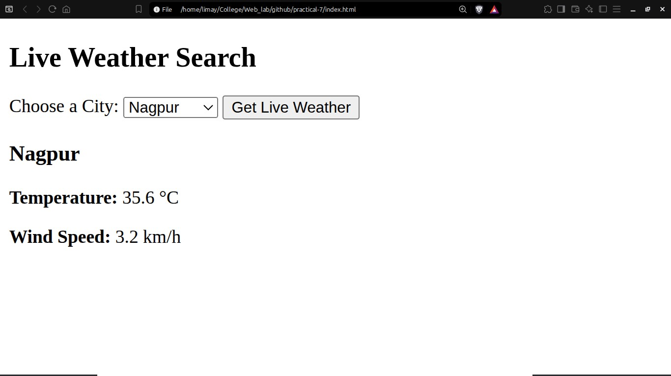
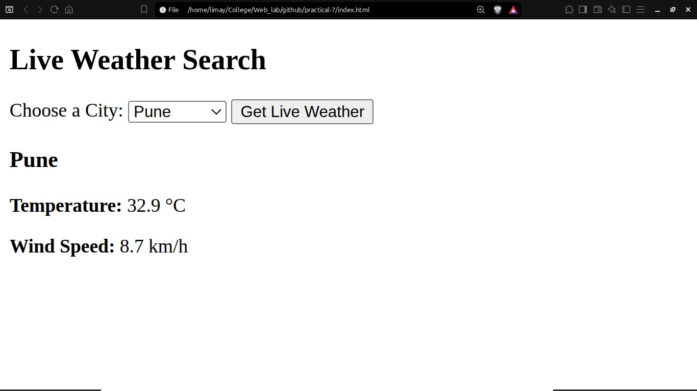
Output Analysis | Initial State: Displays a card with a city dropdown selector (Nagpur, Pune, Mumbai, New Delhi) and a button labeled Get Live Weather.  - During Request: Upon clicking the button, the result area updates instantly to Fetching live weather data....  - On Success: Once the promise resolves, the API response is rendered dynamically on screen (e.g., Nagpur, Temperature: 28.5 °C, Wind Speed: 12.3 km/h).  - On Error: Displays a red error message if the device loses connectivity or the request fails.

To be a preferred hub for nurturing computer engineering aspirants through innovative, ethical, value-based technical education, impactful research, and industry collaboration, to become successful professionals contributing for the betterment of society.
Mission Statement of the Department.
To nurture computer engineering professionals by offering Dynamic learning environment that encourages problem-solving using emerging technology, National Education Policy aligned evidence-based technical education, fostering ,innovation, research, and industry–institute collaboration & Holistic, ethical and sustainable development for lifelong success.
Link of student Github profile where lab assignment has been uploaded | https://github.com/DevanshuP03
Conclusion | Successfully built and demonstrated a web application utilizing JavaScript asynchronous programming (fetch() API and async/await) to dynamically fetch and display real-time weather data.
Plag Report (Similarity index < 12%) | 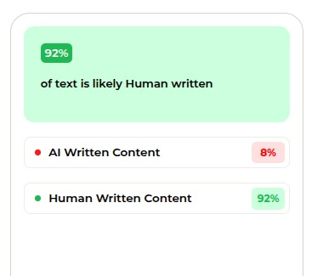
Date | 29/09/2026

